ECE473: Introduction to Artificial Intelligence

Jhen-Ruei Chen

Prof. Xiaoqian Wang

April 29, 2021

Bonus Assignment: Essay on AI Application

Throughout these couple of years, there’s a rapid rise in AI development. The concept of AI was first introduced in 1956 by John McCarthy. In just less than 70 years, the AI system is everywhere in our life from home devices, entertainment, or even transportation. Google home mini, as a home device example, can solve a lot of easy house issues for us and make our life easier and more convenient. Besides this, there is also an AI system that was famous several years ago, the AlphaGo. It calculates all the possibilities on a board game and defeats the best Go player in the world in 2016. The AI system has gotten stronger and stronger throughout these years. As a computer engineering student, I’ve dealt with a lot of computer-based electronic projects and one of the most interesting applications toward AI is the autonomous vehicle.

Throughout the history of the autonomous vehicle. In the 1939 GM’s exhibit, Norman Bel Geddes uses the strategy of radio-controlled electromagnetic fields to create the first self-driving car. Then GM (General Motors) made this concept into a reality. In 1977, Japan’s Tsukuba Mechanical Engineering Lab creates the first semi-automated card by using two cameras and an analog computer. However, the speed is only below 30 km/h with elevated rail supported. By 1987, a project funded by the US’s DARPA makes the self-driving car on a two-lane road with obstacles avoidance and off-road driving in day and night situations. Then in 1995, the US complete the first coast-to-coast drive with an average speed of 102.7km/h. Then in 2015, the US allowed testing the automated cars in some states. In March 2019, a racing series, Roborace, set the fastest self-driving car record with 282.42 km/h. In 2021, Honda leasing out the approved Level 3 automated driving equipment, and it is granted by the government that drivers can “take their eyes off the road”. As we can see, throughout these 80 years, the self-driving system has improved so much that makes out life even easier and more convenient. Shortly, as a report from Market Analysis Report shown in figure 1, the demand for autonomous vehicles will increase rapidly in the near 10 years.

As a computer engineering student, I’m interested in this application because I really want to find a way to make our life more convenient and safer. Take a car accident back in Taiwan last year. A truck was overturned on the highway. Meanwhile, a Tesla car was using an automatic driving system on the highway. However, the Tesla car directly crashed into the truck without slowing down itself and causing the driver to be injured. Two issues are rising with this accident. The first question is that does the driver need to pay any attention to driving an automated car? The second question is that why the Tesla car didn’t recognize the huge truck obstacle. As you can see, with the automated driving system, it is possible that people don’t pay attention while driving. People will think that driving in an automated car means that people can relax and ignore any dangers. However, the Tesla car didn’t recognize the truck is also and really serious issue as well. To me, I think the automated car might have accidentally recognized the truck as a road sign, and this causes the accident. This gives out an alert to a lot of people about the unsafety of automated driving vehicles. According to figure 2 from statista.com, most people think that self-driving cars are very unsafe or somewhat unsafe, and people are less confident throughout the time. As a result, it is really important to recover people’s confidence in the AI system. I think Automated Vehicles is one of the most important applications for AI and I’m really interested in applying this area and hopefully, I can apply my skills to improve the Automated Driving field.

There is positive and negative side when it comes to the automated driving system. As described previously, one of the biggest concerns for the automated driving system is that the AI system might accidentally recognize an obstacle as a road sign and crashed into it and this may cause the death or injury of people. To solve this issue, it is essential how AI works. It is also essential to give the AI learning system really specific and strict criteria so that they must follow the rules. If we didn’t give the AI a specific enough criterion, they might have a chance to find the bug and have the same result as the Tesla accident in Taiwan. As a result, it is essential to train the AI system as much as possible on a simulation to prevent this kind of accident. Besides this, I think it is also important to set up policies specific to autonomous vehicles. Based on figure 3, people have a strong favor on setting up policies such as requiring a person in driver’s seat, travel in special lanes, or restricting driving near schools, and so on.

However, on the other hand, there are pros side to the automated driving system. This technique makes people’s life easier and more convenient. Based on figure 4, from the Society of Automotive Engineers (SAE), there are 6 levels, from 0 to 5, in the automated system. 0 indicates no autonomous features in the vehicle and the highest, level 5, means that people don’t need to keep an eye on the road, or drivers are not required. If we can implement level 5 automation in the future and make sure that it is safe enough, then it will benefit our life. According to figure 5, there are more than 56% of US adults believe that most cars will be driverless within the next half-century. The automated Driving car will make our life easier and more convenient without worrying about safety while sitting in the car. Thinking about that in the near future, there won’t be any people in the driver position instead of a computer in there, it makes people excited. People can simply relax and sleep and when they wake up, they’re at the destination.

Throughout this self-driving car application, one thing that I learned is that some self-driving car has a process of deciding whether the car’s action such as stopping or speeding up. With a further investigation, this is relevant to Markov Decision Process. This brief knowledge helps me learn ECE473 better because this gives me an idea of why the Markov Decision Process is important in the AI world and how the Markov Decision Process works. This knowledge becomes basic and with the implementation of one of our homework, I was able to understand this decision process more deeply and have confidence for future work.

As the AI application from different fields has become more and more popular and most of the AI system has its learning system. The question comes to that will AI has self-awareness. Within the paper from George Hurlburt, it is clear that AI might develop its own thinking eventually. For a machine to develop its own thinking ability, it’ll need to act like a human brain (Hurlburt, 2017). With self-awareness, AI will have their own self-awareness to prevent losing energy or develop a way to store their energy. Since a machine requires electronics, they will concern about where their “life support” comes from. Just like humans develop ways to store water, AI will develop ways to store electricity or energy. The other things about AI that people need to be aware of are their setting and usage. With one step wrong, we might make us into a situation that cannot be recovered. Take one extreme example, if we have a system that the final result is to find a solution to improve our Earth or prevent pollution. If we didn’t set up any criteria. It might determine that human is the biggest threat to Earth and eliminating human will be the solution. Thus, it is important for us to set up the AI system correctly.

It is important to develop AI applications throughout the world. However, it is also important to have the restriction on where the AI application can be used. Although it seems like AI is benefiting our life right now from every aspect, we cannot trust AI too much. Otherwise, we may end up like the Tesla auto-driving accident. We still need to remain doubtful while using AI wisely. Meanwhile, I think learning AI is a fun process. Throughout this paper and the entire ECE473 course, I found out AI has some “beautiful” processes that interesting me a lot. For example, AI can develop a winning strategy on gaming by going through a lot of simulations, or it can quickly help us determine the spam emails and so on. With just an input, we can easily get the answer or a solution we want without going through our brain too much. In my opinion, I think AI will be the lead in our future. Therefore, it is important for us to learn AI skills and understand how to implement them in our life and makes our future easier and more convenient.

Reference Page:

Autonomous Vehicle Market Size & Share Report, 2021-2030. (2020, March). https://www.grandviewresearch.com/industry-analysis/autonomous-vehicles-market.

Hurlburt, G. (2017). Superintelligence: Myth or Pressing Reality?. *IT Professional, 19*(1), 6-11. Retrieved March 20, 2020, from <https://ieeexplore.ieee.org/document/7839873>

Richter, F. (2019, May 3). *Infographic: Self-Driving Cars Still Cause for Concern for Pedestrains*. Statista Infographics. https://www.statista.com/chart/17881/self-driving-car-safety/.

Shuttleworth, J. (2020, May 15). *SAE J3016 automated-driving graphic*. SAE International. https://www.sae.org/news/2019/01/sae-updates-j3016-automated-driving-graphic.

Smith, A., & Anderson, M. (2019, December 31). *Americans' views on driverless vehicles*. Pew Research Center: Internet, Science & Tech. https://www.pewresearch.org/internet/2017/10/04/americans-attitudes-toward-driverless-vehicles/.

Templeton, Brad. “Tesla In Taiwan Crashes Directly Into Overturned Truck, Ignores Pedestrian, With Autopilot On.” *Forbes*, Forbes Magazine, 15 Dec. 2020, www.forbes.com/sites/bradtempleton/2020/06/02/tesla-in-taiwan-crashes-directly-into-overturned-truck-ignores-pedestrian-with-autopilot-on/?sh=720a5fc58e56.

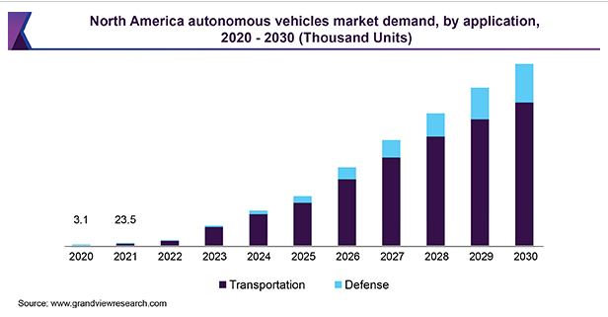

Figure 1

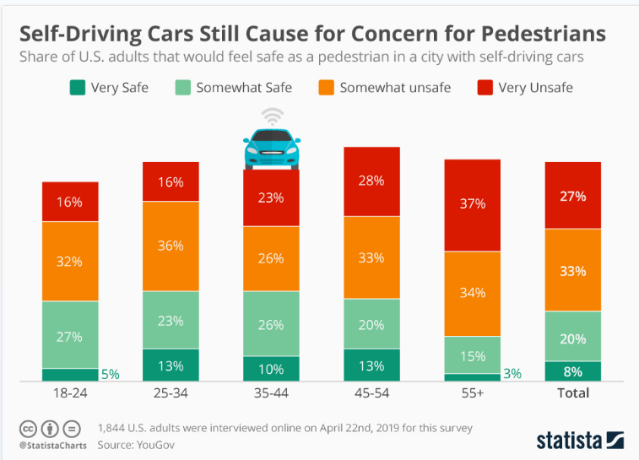

Figure 2

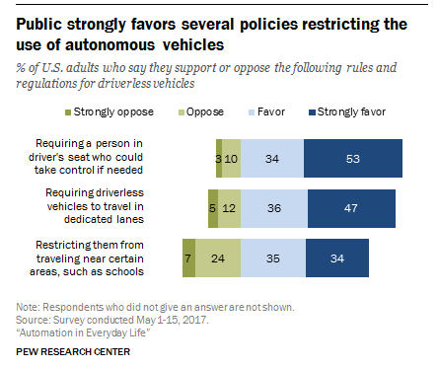

Figure 3

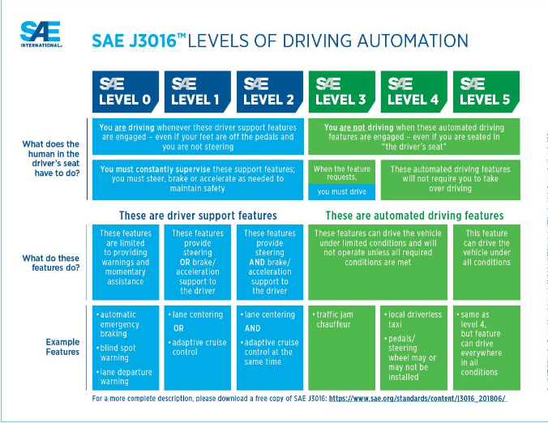

Figure 4

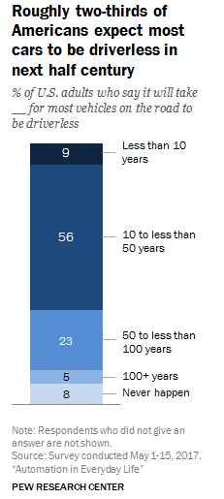

Figure 5